5.107: a) The forces on the car are the air drag force 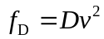 and the rolling friction force 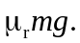 Take the velocity to be in the 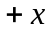-direction. The forces are opposite in direction to the velocity. 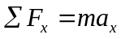 gives
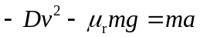
We can write this equation twice, once with 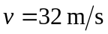 and 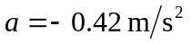 and once with 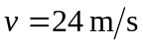 and 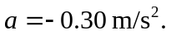 Solving these two simultaneous equations in the unknowns D and 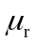 gives 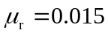 and 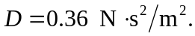
b) 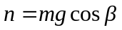 and the component of gravity parallel to the incline is 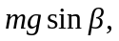 where 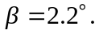
For constant speed,
Solving for gives 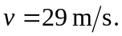
c) For angle 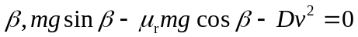
and 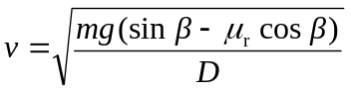
The terminal speed for a falling object is derived from 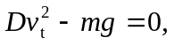 so 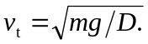
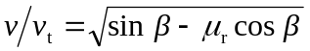
And since 